**01-Split Shadow Project**

First we have to create an ***index.html*** file and ***style.css***

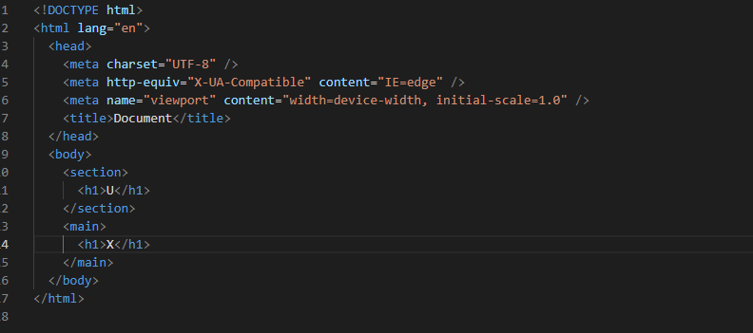

**Output**

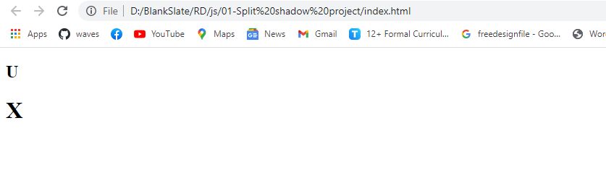

**Now Add Some Css**

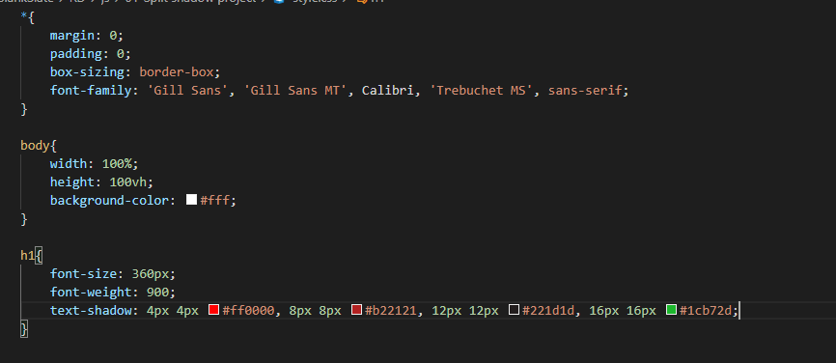

**Output**



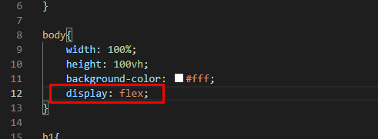

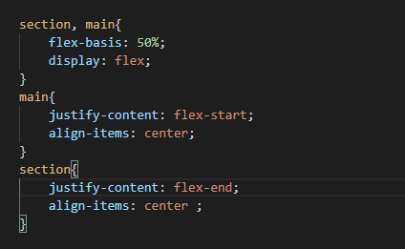

**Flex-basis** specifies the initial size of the flex item

**Output**



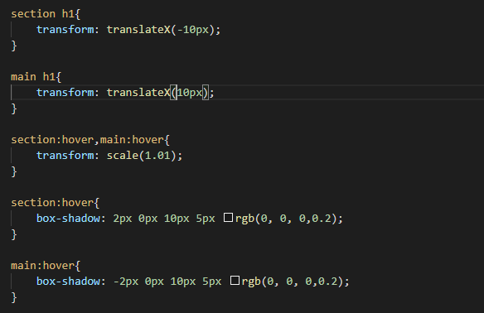

**Box Shadow**

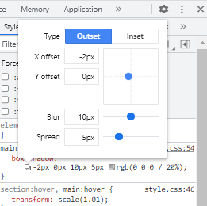

**Output**



Now we have to remove the Transform and Text Shadow on hover.

section:hover h1,main:hover h1{

    transform: translateX(0);

    text-shadow: none;

}



**For Smoothness**

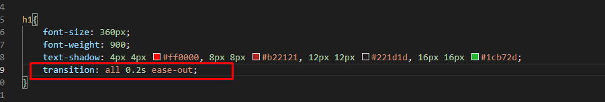

**To remove Overflow**

